# [Introduction to Probability](https://www.amazon.com/Introduction-Probability-Chapman-Statistical-Science/dp/1138369918/ref=cm_cr_arp_d_product_top?ie=UTF8)

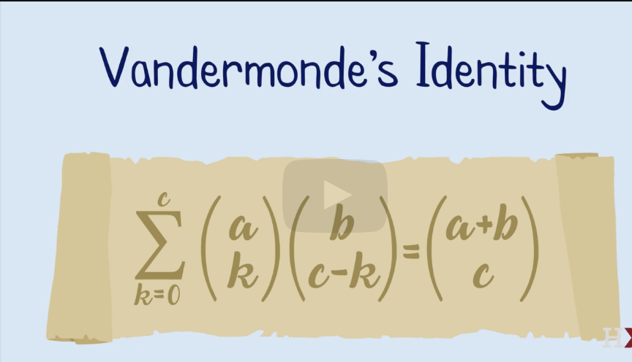

Story

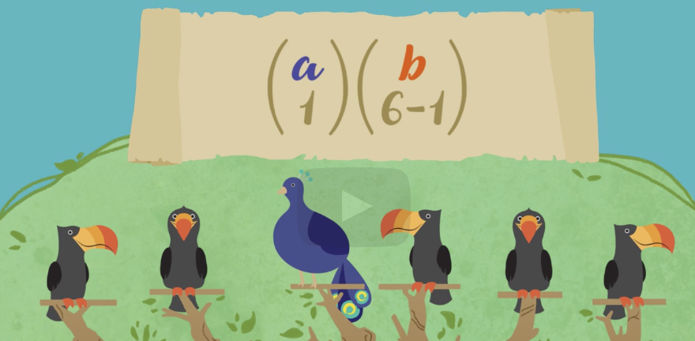 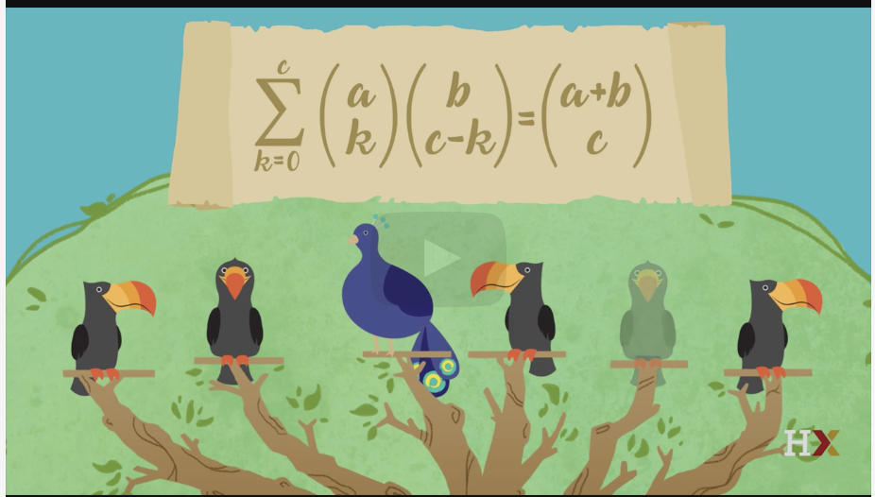

Binomial coefficients tell us **how many ways there are to choose *k* things out of a larger set**. More formally, they are defined as the coefficients for each term in (1+x)n. Written asbinomial coefficient, (read n choose k), wherebinomial coefficientis the binomial coefficient of the xk term of the polynomial.**An alternate notation is nCk.**

For [non-negative integer](https://www.statisticshowto.com/non-negative-integer/) values of n (number in the set) and k (number of items you choose), every binomial coefficient nCk is given by the formula:



## Importance in Statistics

The binomial coefficient is much more than just a simple formula to calculate how many ways you can pull an advisory board from a candidate pool, It’s also part of the description of the [binomial distribution,](https://www.statisticshowto.com/probability-and-statistics/binomial-theorem/binomial-distribution-formula/) a simple [probability distribution](https://www.statisticshowto.com/probability-distribution/) for frequently encountered 2-outcome situations.

If your observations are [independent](https://www.statisticshowto.com/independent-random-variables/), each represents one of two outcomes (think: success and failure), your number of trials are fixed and the probability of success is the same for each trial, then the probability you have exactly r successes during your n independent trials will be



This formula represents the binomial distribution. Here p is the probability of success in each instance, and q=1-p, the probability of failure.

The binomial coefficient n choose r tells you how many success-failure sequences, of the set of all possible sequences, will result in exactly r successes. The probability of each of those individual sequences happening is just prqn-

Sample Space And Event

The *sample space* of an experiment is the set of all possible outcomes of the experiment. An *event* is a subset of the sample space , and we say that *occurred* if the actual outcome is in .

Sample space can be finite or in-finite. Sample space is called Pebble World if the outcomes are finite.

Truth Table of A => B

A | B |A->B

T | T | T

T | F | F

F | T | T

F | F | T

A⟹B means intuitively "B is not more false than A". So if A is false, then nothing is more false, any B is no more false than A, and the implication is true.

The key here is the difference between 𝐴⇒𝐵 and A⇔B (A implies B and B also implies A). Consider the logical statements A = "it is night" and B = "I cannot see the Sun".

A implies B here (if it's night I can't see the Sun, at least from this part of the Earth), but

B does not imply 𝐴. It could be cloudy, or an eclipse, or I could be indoors, et cetera.

The statement A⇒B doesn't make any claim about whether B also implies A. Defining it this way makes certain things a lot easier, since we can now say (e.g.)

x>7⇒x>5. This is a true mathematical statement (A⇒B) for real x. In other words,

A⇒B is true. But what if we let 𝑥=6 ? Now

B is true but A is false; yet you'd still agree that A⇒B is true. It just so happens that

A is false in this one case; that doesn't impact the overall truth or falsehood of 𝐴⇒𝐵.

And yes, this does mean that a falsehood implies anything. "If 2+2=5, then I am a penguin" is a true implication. This is called "Ex Falso Sequitur Quodlibet" (from a false thing, anything you want results) or the "Principle of Explosion". If you assume a contradiction (i.e. something false also being true) you can derive anything else.

Set Theory Refresher

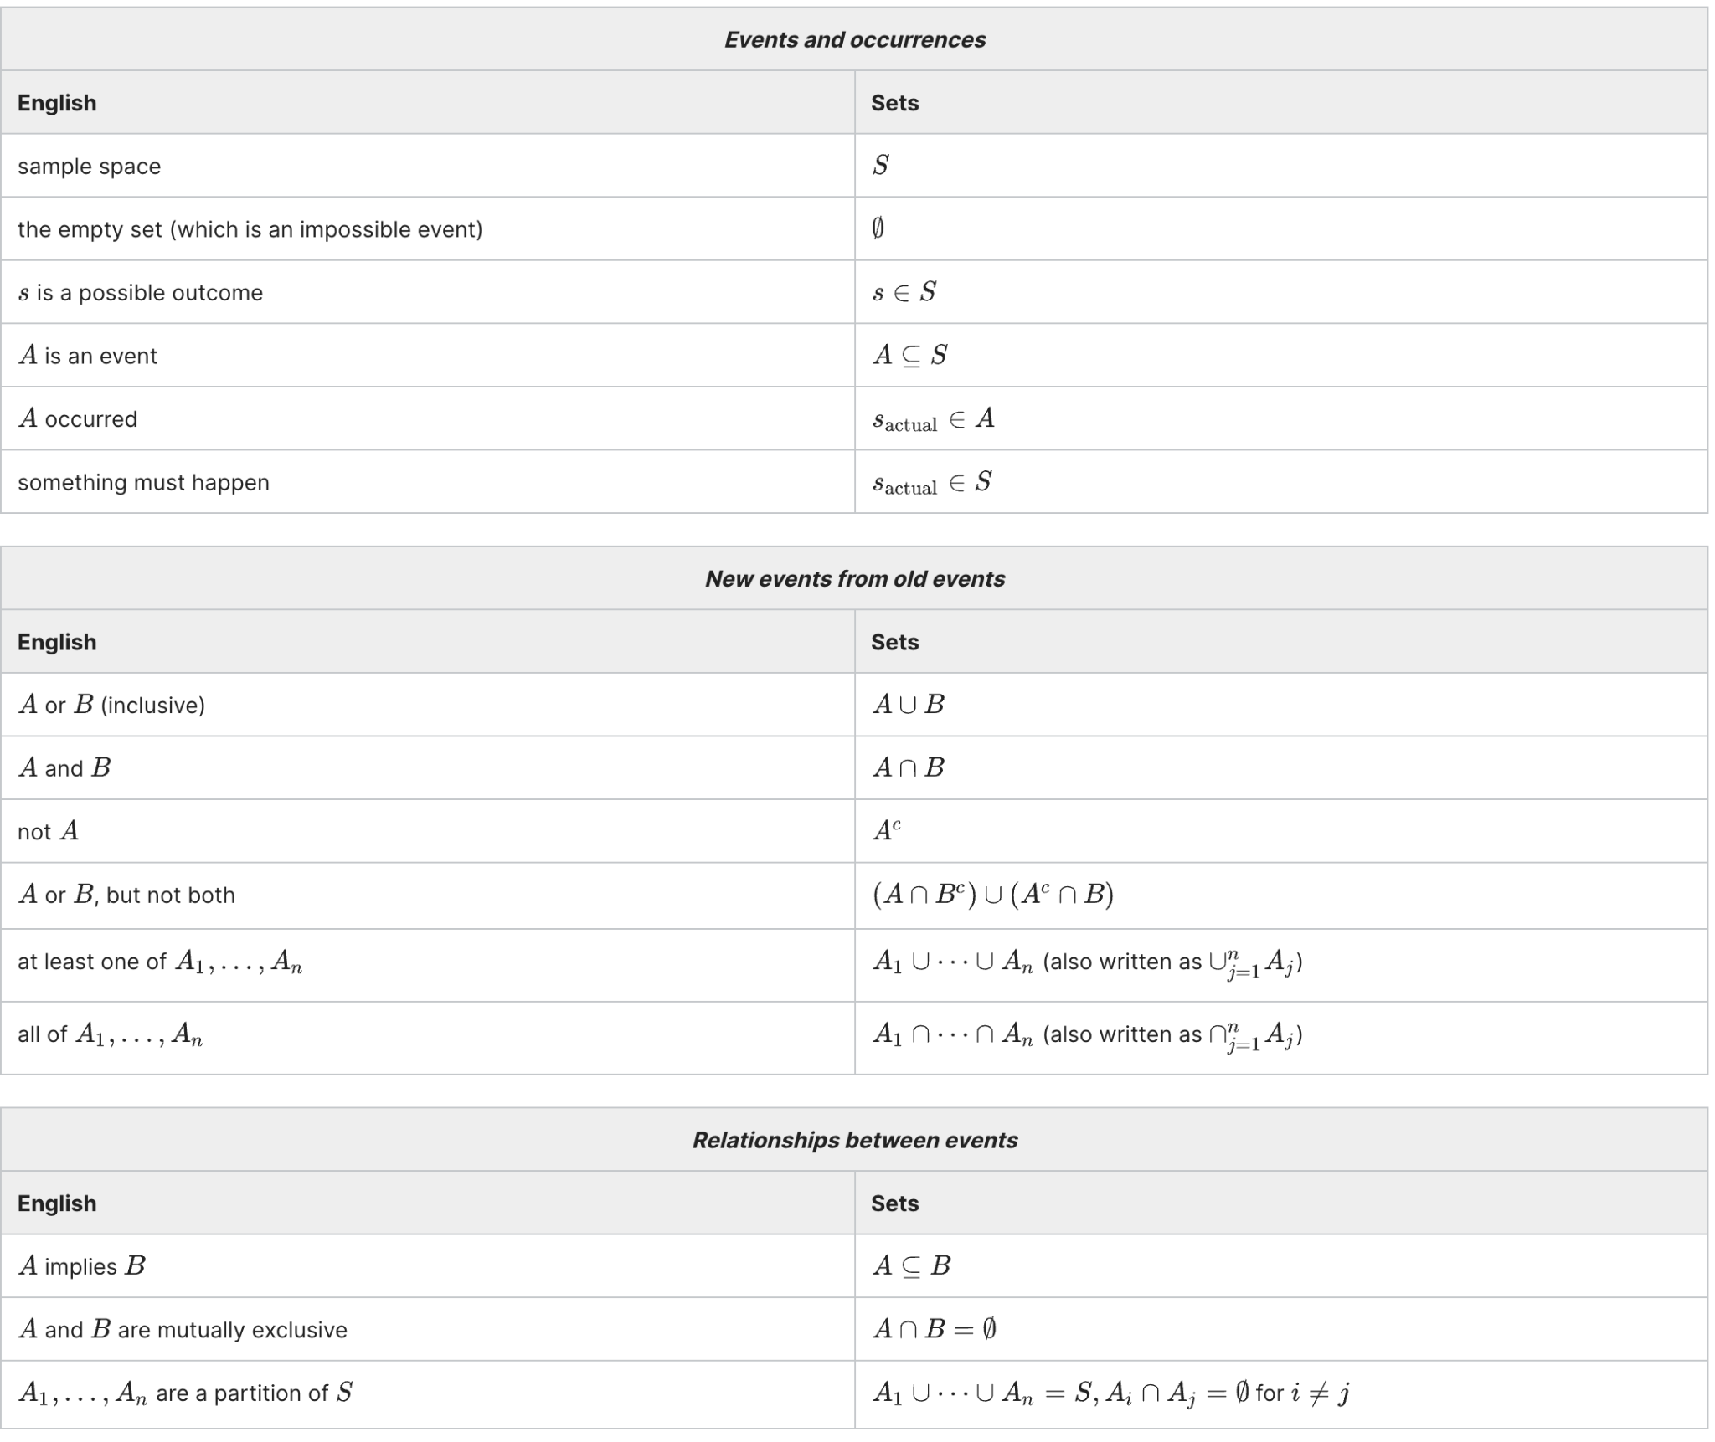

Coin Flipping :

KEY NOTES : - Sample Space is the set of all possible strings of length 10 of H and T.

Possible Outcome is always either 0 or 1. If event 1 is head ; then sj is still 0, 1 with 2 , 10.

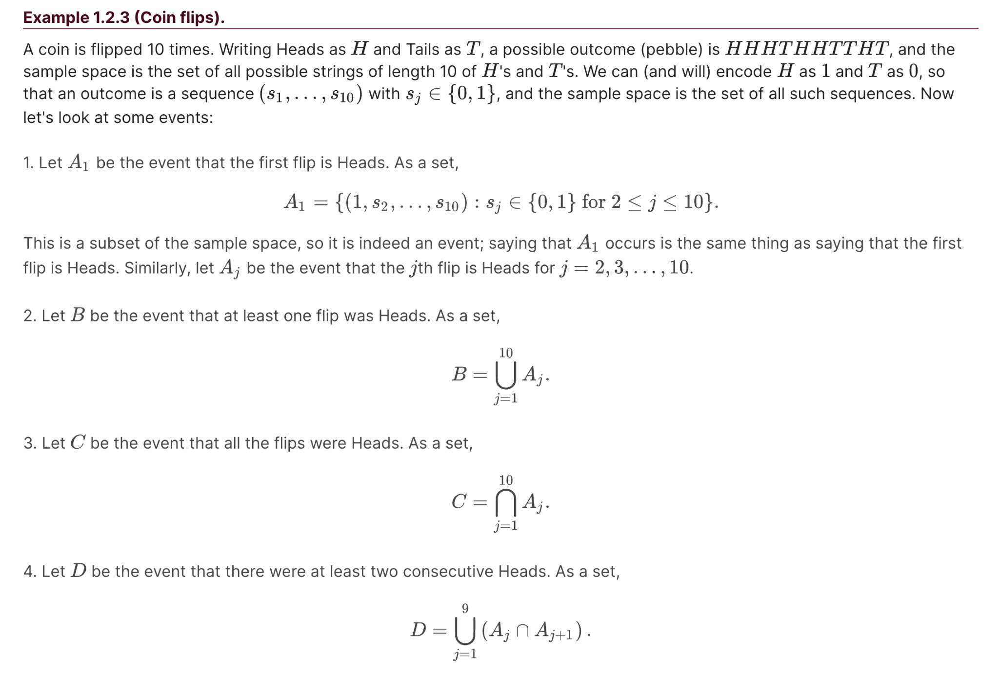

#### **(Naive definition of probability).**

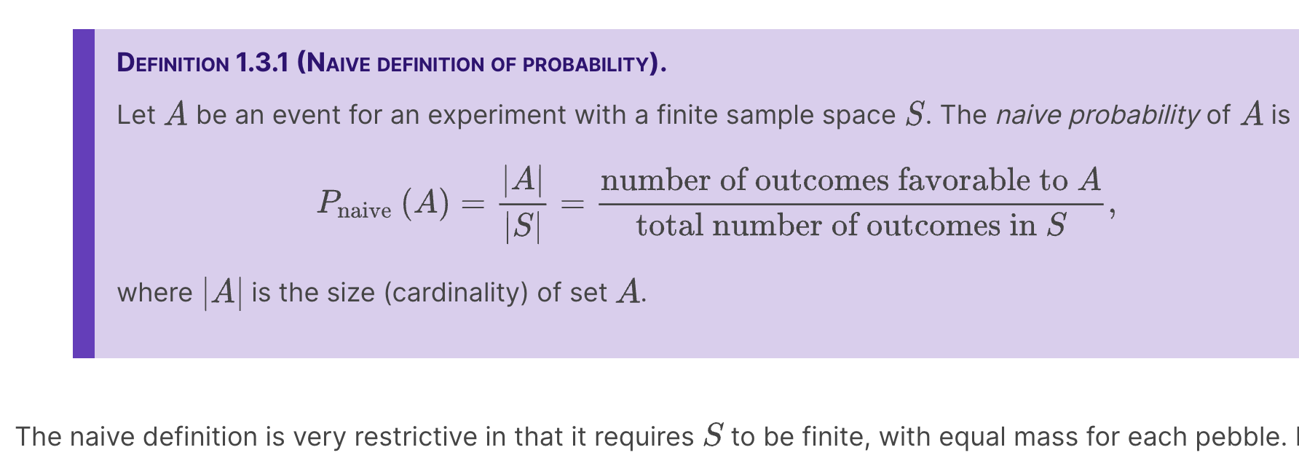

Calculating the naive probability of an event involves counting the number of pebbles in and the number of pebbles in the sample space . Often the sets we need to count are extremely large, so it would be tedious or infeasible to count the possibilities one by one.

#### **Theorem 1.4.1 (Multiplication rule).**

Consider a compound experiment consisting of two sub-experiments, Experiment A and Experiment B. Suppose that Experiment A has possible outcomes, and for each of those outcomes Experiment B has possible outcomes. Then the compound experiment has possible outcomes.

Eg: Two types of ice cream cone ; with 3 flavors. Then if it's available now or not ; its 6 possibilities.

If for some reason if one flavor is not available for a type of cone , then the multiplication rule is not applied.

We can use the multiplication rule to arrive at formulas for sampling with and without replacement. Many experiments in probability and statistics can be interpreted in one of these two contexts, so it is appealing that both formulas follow directly from the same basic counting principle.

#### **Theorem 1.4.5 (Sampling with replacement).**

Consider n objects and make k choices from them, one at a time *with replacement* (i.e., choosing a certain object does not preclude it from being chosen again). Then there are nk possible outcomes.

#### **Theorem 1.4.6 (Sampling without replacement).**

Consider n objects and make k choices from them, one at a time *without replacement* (i.e., choosing a certain object precludes it from being chosen again). Then there are n(n-1)...(n-k+1) possible outcomes, for k ≤ n(and 0 possibilities for k > n).’

**Warning 1.4.10 (Labeling objects).**

Drawing a sample from a population is a very fundamental concept in statistics. It is important to think of the objects or people in the population as *named* or *labeled*. For example, if there are n balls in a jar, we can imagine that they have labels from 1 to n , even if the balls look the same to the human eye. In the birthday problem, we can give each person an ID (identification) number, rather than thinking of the people as indistinguishable particles or a faceless mob.

Why Binomial Coefficient?

Adjustment for overcounting , like 3 ppl in a 2 member committee , probability is just 2. But with the theory of multiplication it's 6.

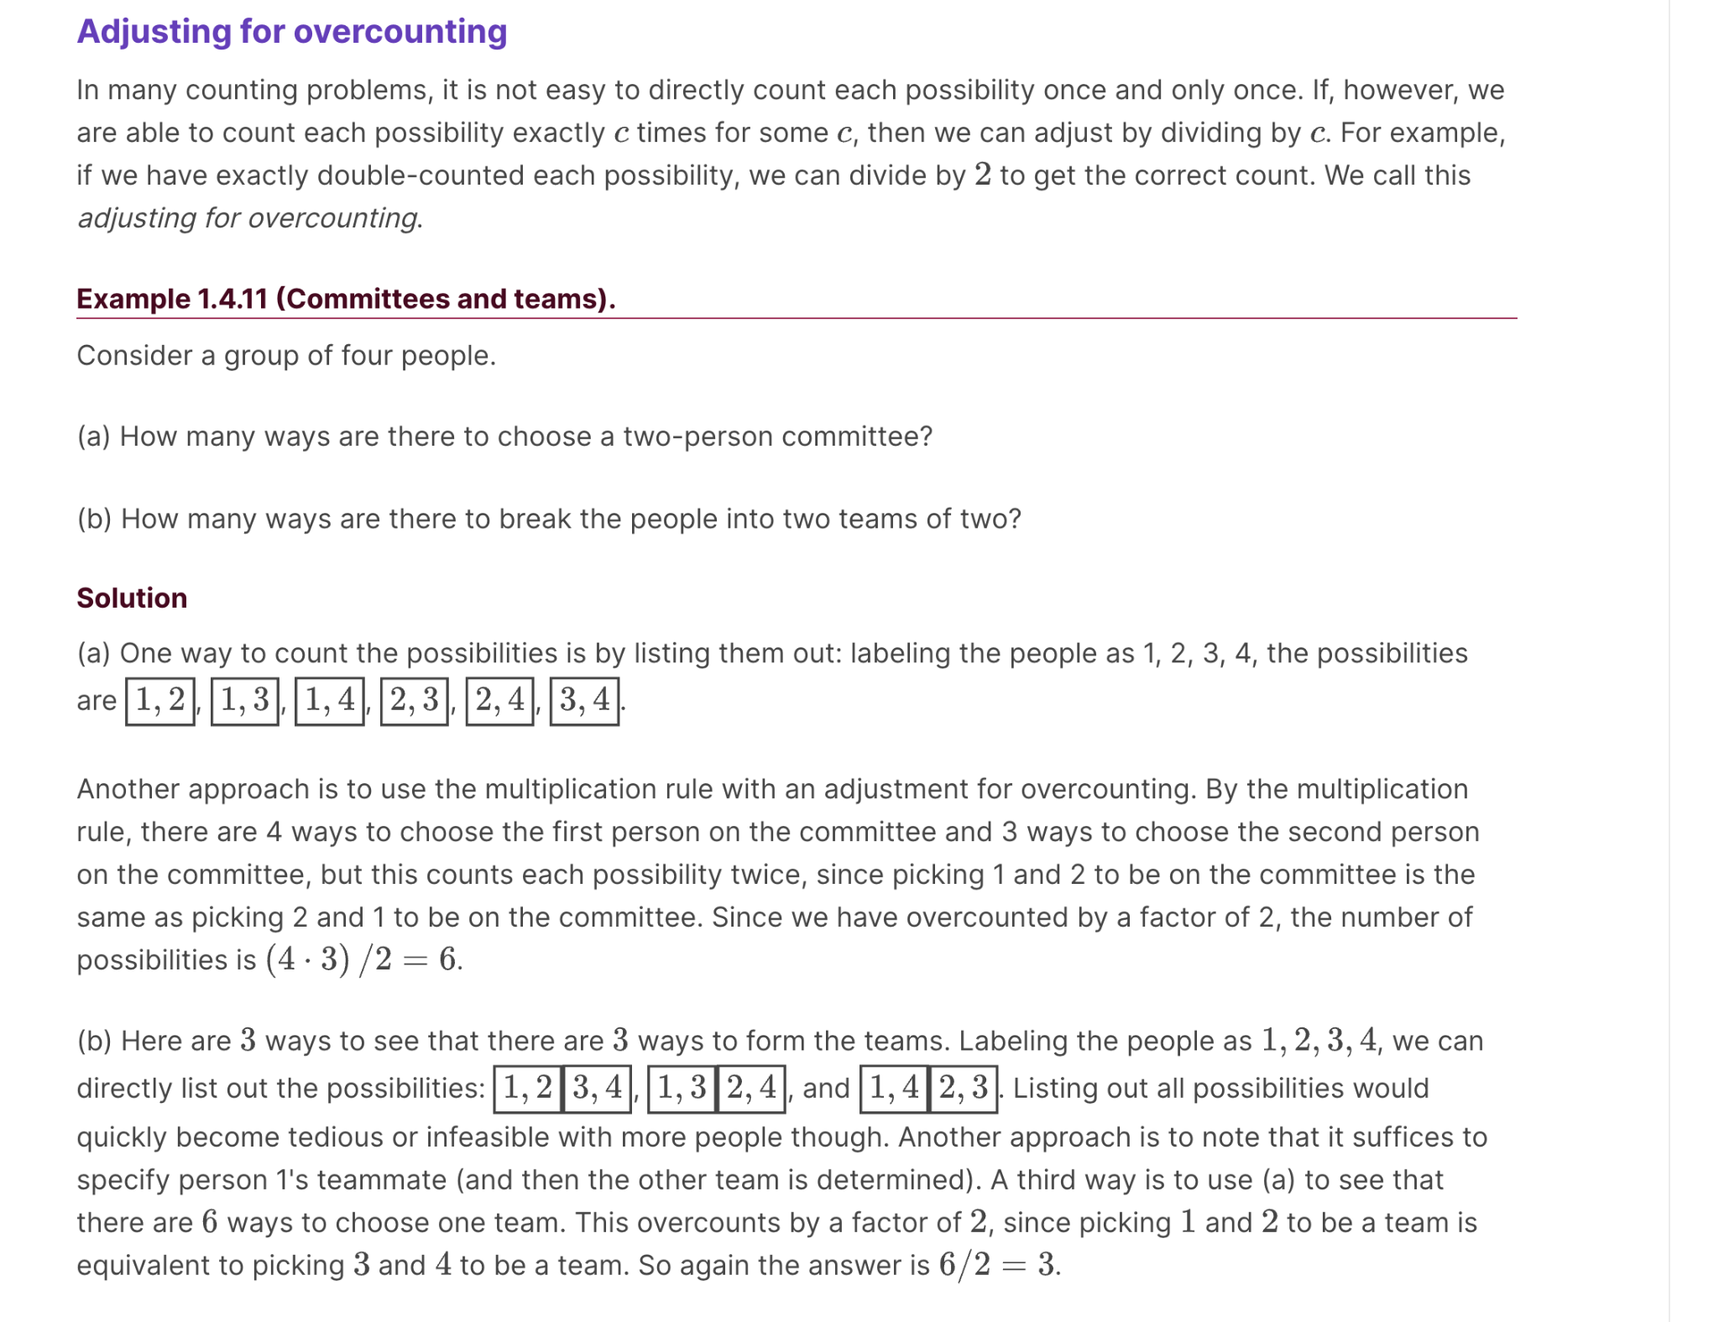

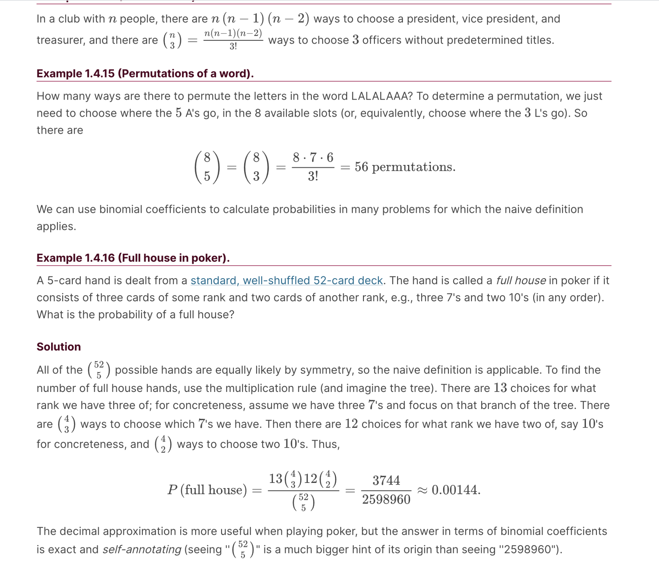

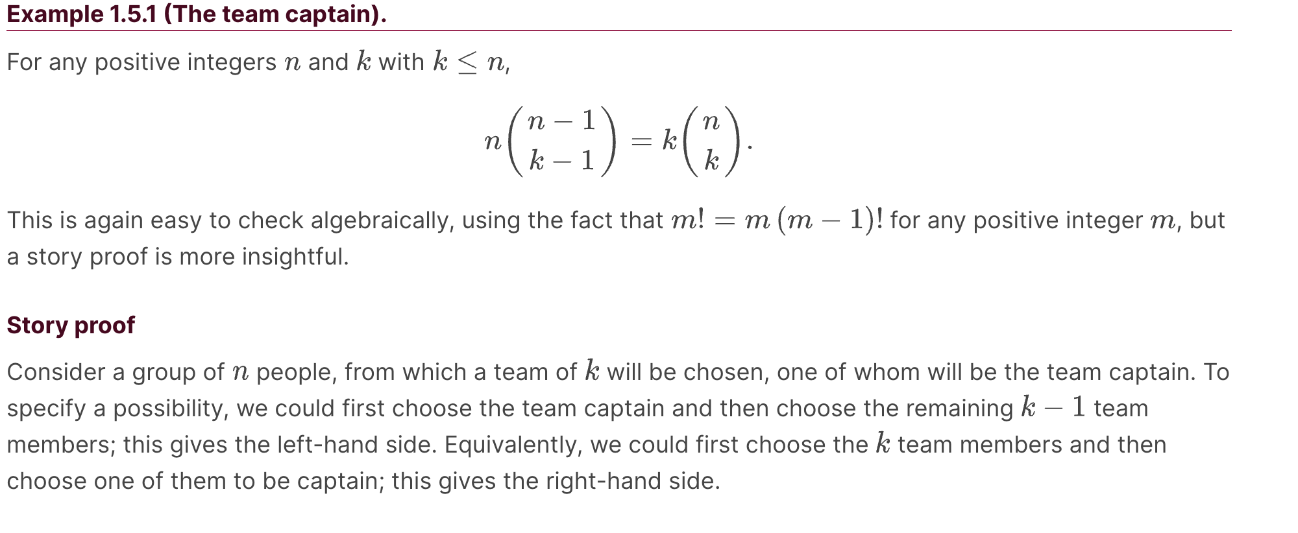

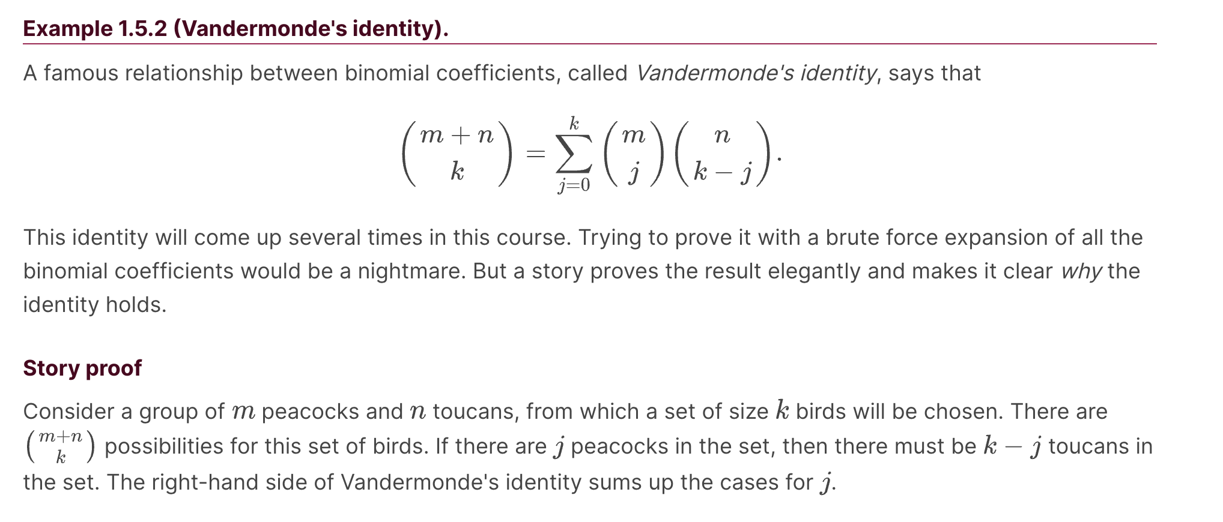

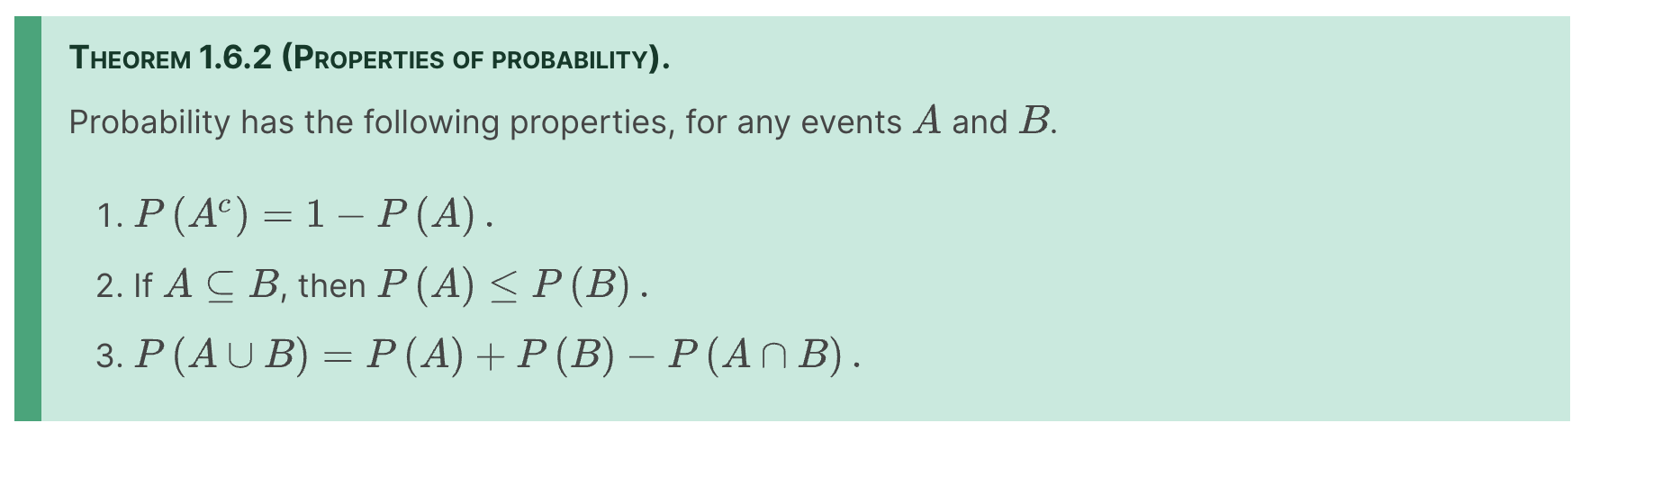

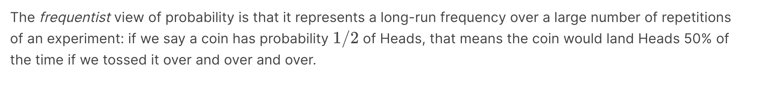

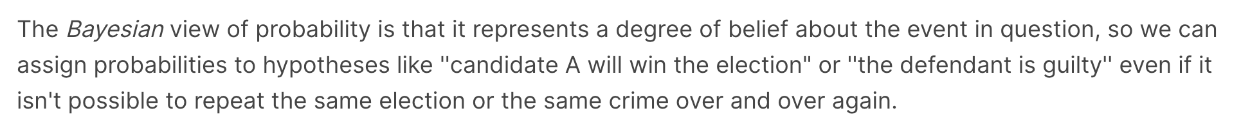

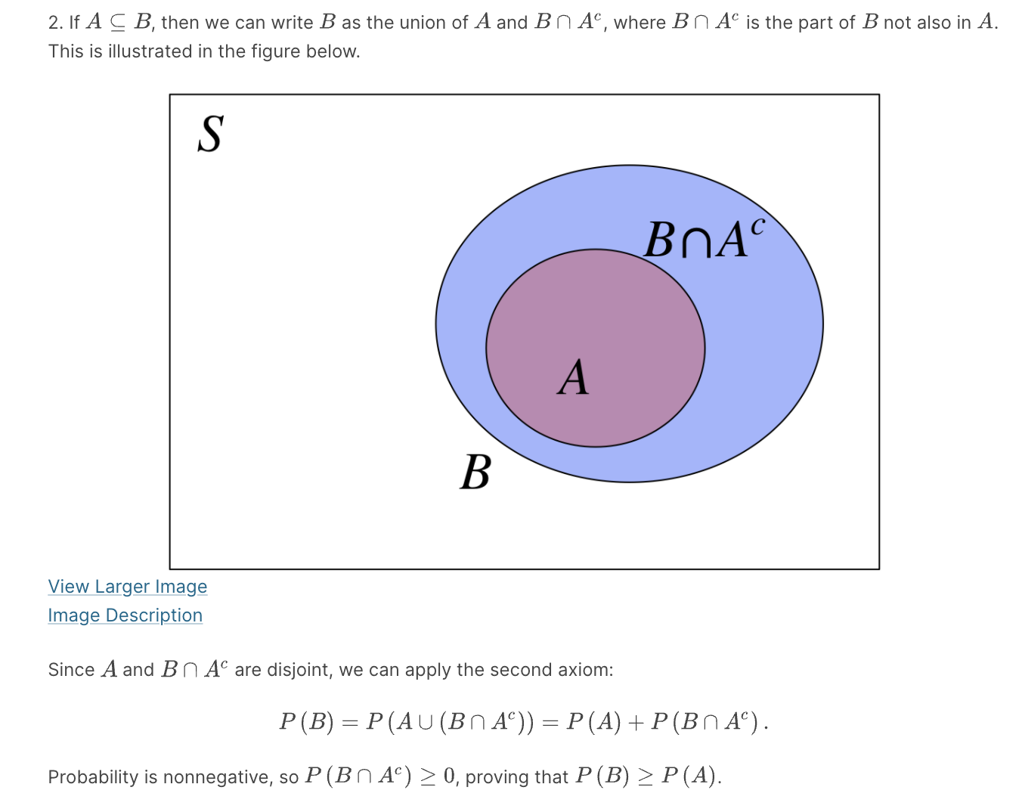

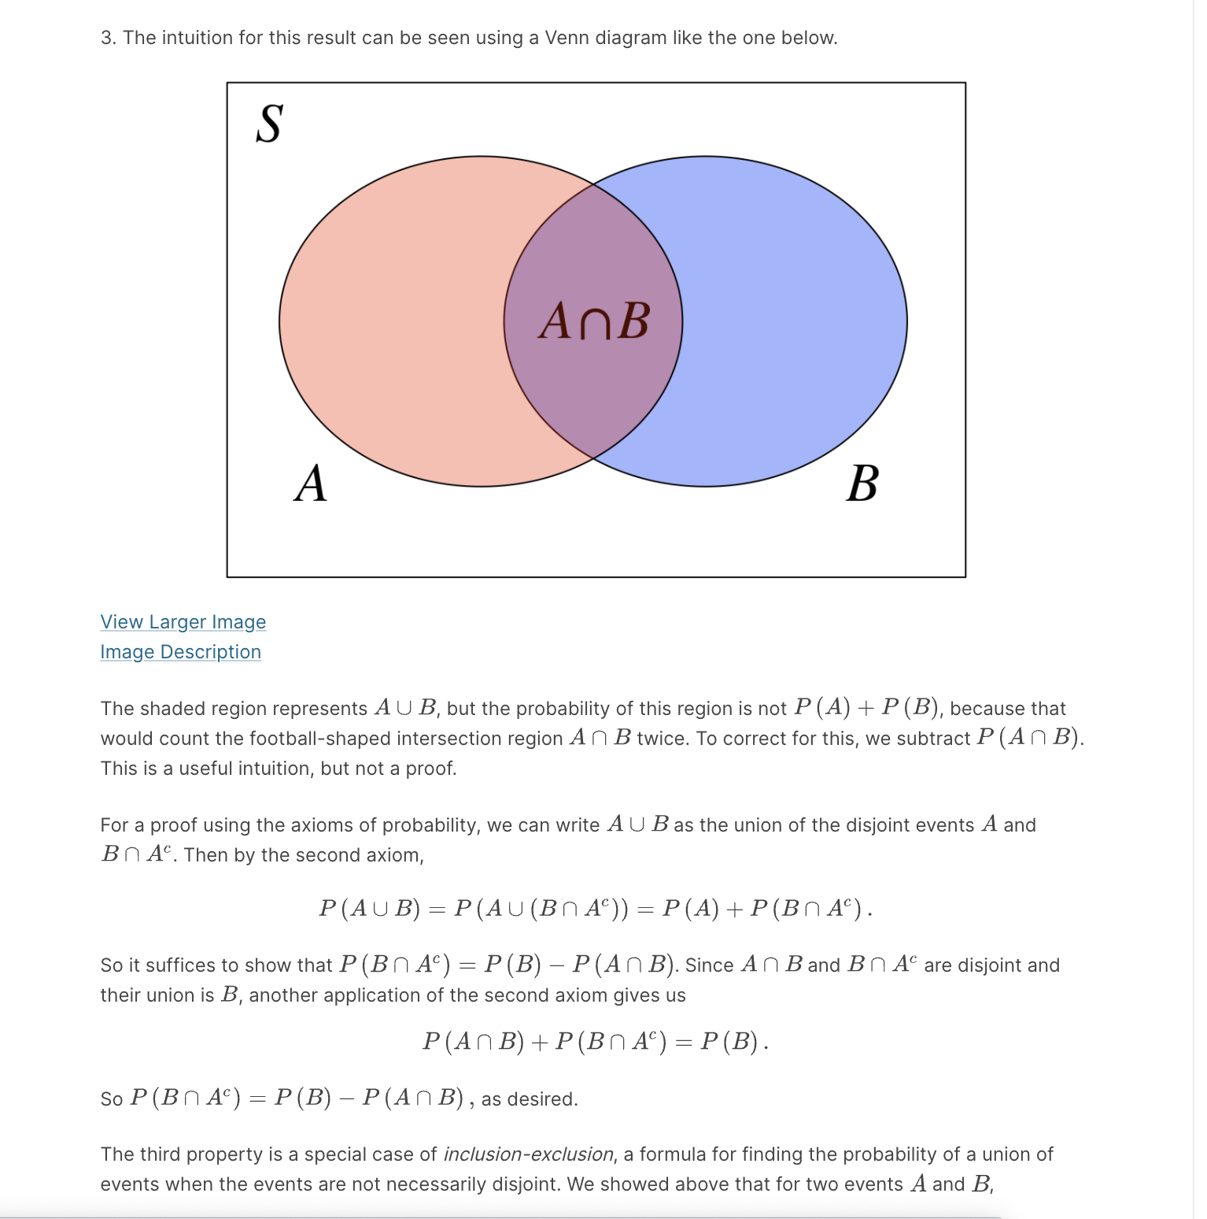

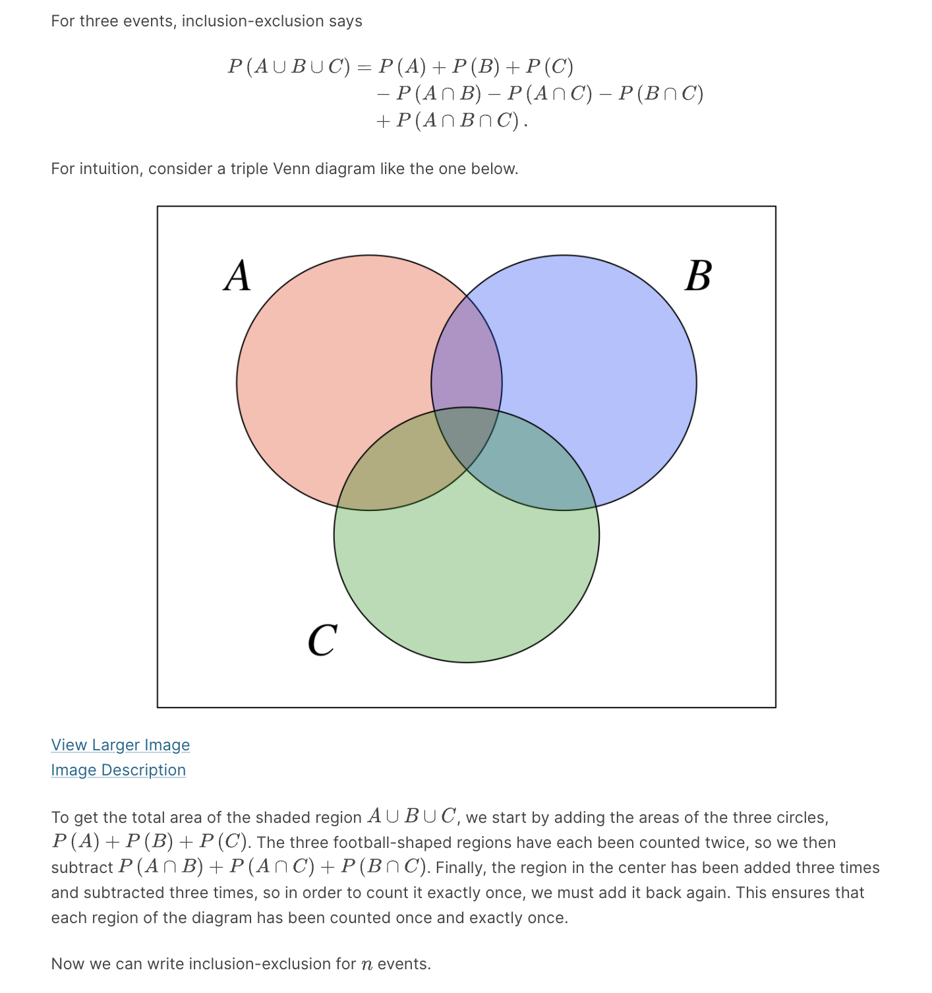

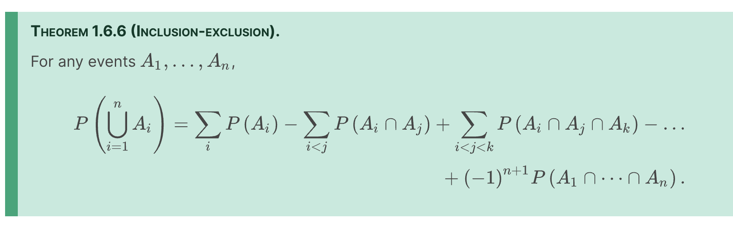

*de Montmort's matching problem*, is a famous application of inclusion-exclusion. Pierre Rémond de Montmort was a French mathematician who studied probability in the context of gambling and wrote a treatise devoted to the analysis of various card games. He posed the following problem in 1708, based on a card game called Treize.

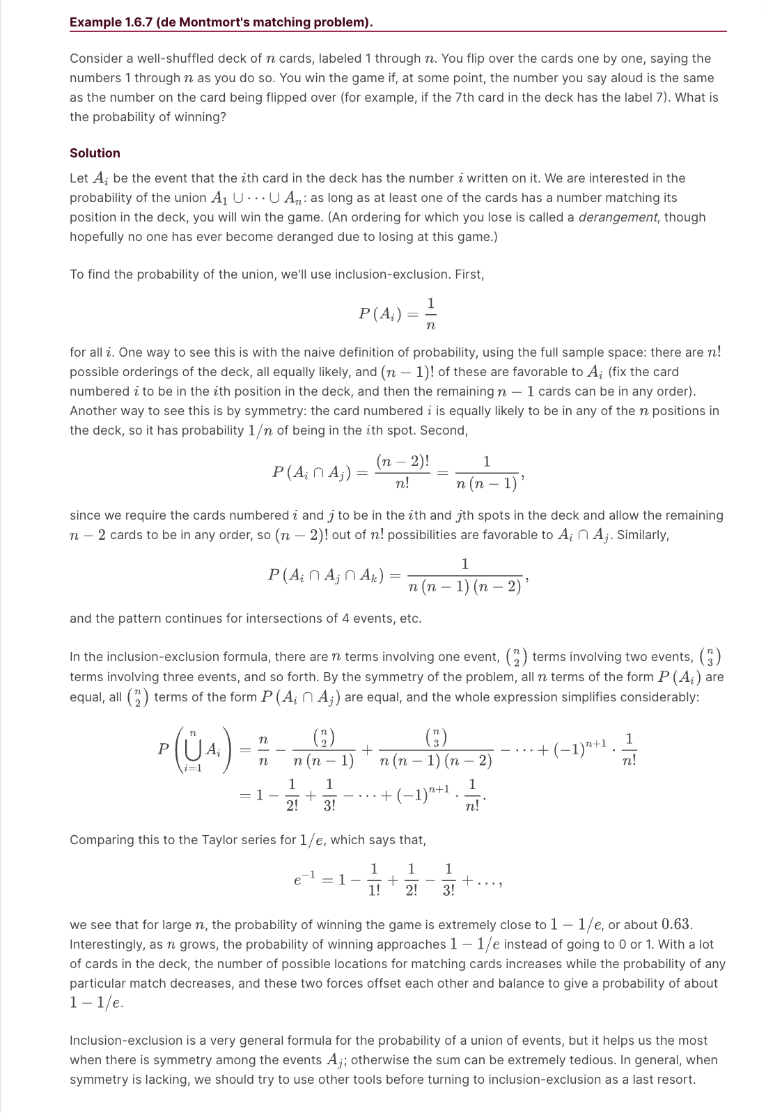

Problems :



(12 choose 2) (10 choose 5) / 2 !

